c prog 19-5 home assignment

HA10.1 WAP which produces its own source code as its output.

#include <stdio.h>

int main() {

FILE *fp_3260;

int c;

fp_3260 = fopen(__FILE__,"r");

do {

c = getc(fp_3260);

putchar(c);

}

while(c != EOF);

fclose(fp_3260);

return 0;

}

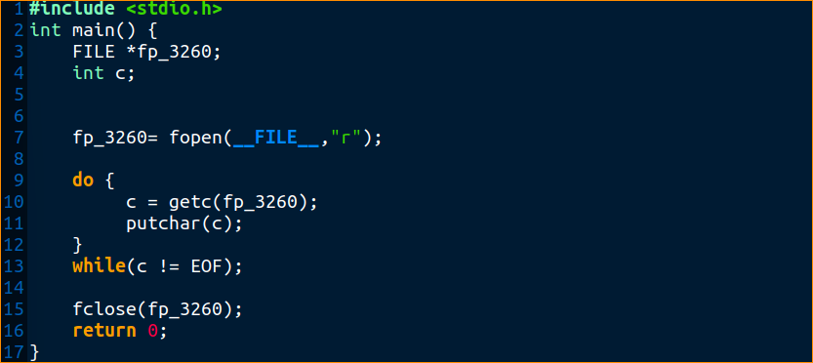

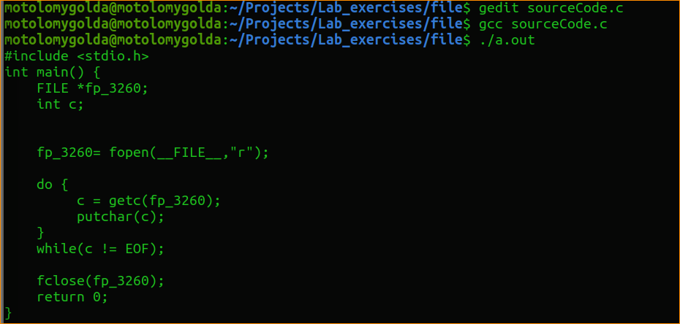

HA10.2 WAP to copy the specified bytes from given offset of a file and write them into another file.

#include <stdio.h>

#include <string.h>

#include <stdlib.h>

int main(int argc,char *argv[])

{

FILE *fp1_3260;

FILE *fp2_3260;

int count = 0;

int location = 0;

int totBytes = 0;

char filename[100], filename1[100];

printf("Enter the filename you want copy: ");

scanf("%s", filename);

printf("Enter the filename you want it copied it to: ");

scanf("%s", filename1);

unsigned char data[1024];

if( argc < 5 )

{

printf("Insufficient Arguments!!!\n");

printf("Please use \"program-name source-file-name target-file-name offset N\" format.\n");

return -1;

}

fp1_3260 = fopen(filename,"r");

if( fp1_3260 == NULL )

{

printf("\n File can not be opened : \n");

return -1;

}

fseek(fp1_3260,0,SEEK_END);

count = ftell(fp1_3260);

location = atoi(argv[3]); // offset of source file to copy

totBytes = atoi(argv[4]); // number of bytes to copy

if( count < (location + totBytes) )

{

printf("\nGiven number of bytes can not be copy, due to file size.\n");

return -1;

}

fp2_3260 = fopen(filename1,"w");

if( fp2_3260 == NULL )

{

printf("\n File can not be opened\n");

return -1;

}

fseek(fp1_3260,location,SEEK_SET);

fread(data,totBytes,1,fp1_3260);

fwrite(data,totBytes,1,fp2_3260);

data[totBytes]=0;

printf("\nCopied content is : \"%s\"\n",data);

fclose(fp1_3260);

fclose(fp2_3260);

return 0;

}

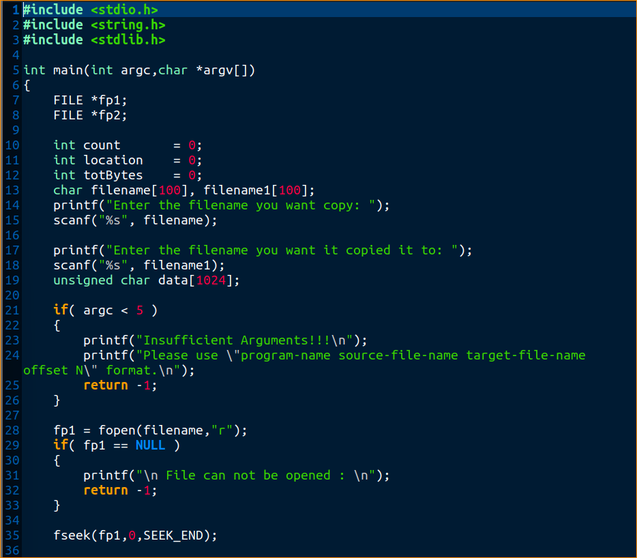

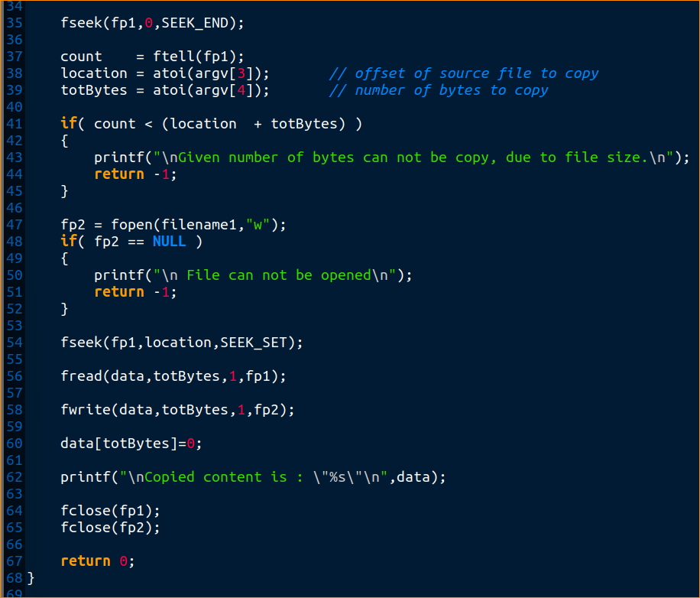

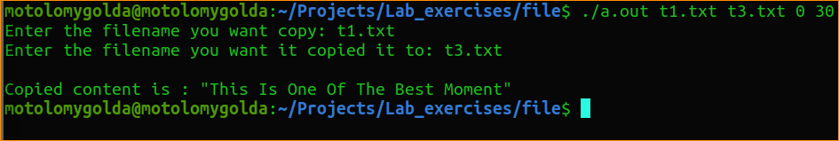

HA10.3 Write a menu driven program to perform the following operations in a file.

a) to delete a specific line from a text file.

b) To replace a specified line by another from a text file.

#include <stdio.h>

#include <string.h>

#define MAX 256

int main()

{

FILE *fptr1_3260, *fptr2_3260;

int lno, linectr = 0;

char str[MAX],fname[MAX];

char newln[MAX], temp[] = "temp.txt";

printf("\n\n Replace a specific line in a text file with a new text :\n");

printf("-------------------------------------------------------------\n");

printf(" Input the file name to be opened : ");

fgets(fname, MAX, stdin);

fname[strlen(fname) - 1] = '\0';

fptr1_3260 = fopen(fname, "r");

if (!fptr1_3260)

{

printf("Unable to open the input file!!\n");

return 0;

}

fptr2_3260 = fopen(temp, "w");

if (!fptr2_3260)

{

printf("Unable to open a temporary file to write!!\n");

fclose(fptr1_3260);

return 0;

}

/* get the new line from the user */

printf(" Input the content of the new line : ");

fgets(newln, MAX, stdin);

/* get the line number to delete the specific line */

printf(" Input the line no you want to replace : ");

scanf("%d", &lno);

lno++;

// copy all contents to the temporary file other except specific line

while (!feof(fptr1_3260))

{

strcpy(str, "\0");

fgets(str, MAX, fptr1_3260);

if (!feof(fptr1_3260))

{

linectr++;

if (linectr != lno)

{

fprintf(fptr2_3260, "%s", str);

}

else

{

fprintf(fptr2_3260, "%s", newln);

}

}

}

fclose(fptr1_3260);

fclose(fptr2_3260);

remove(fname);

rename(temp, fname);

printf(" Replacement did successfully..!! \n");

return 0;

}

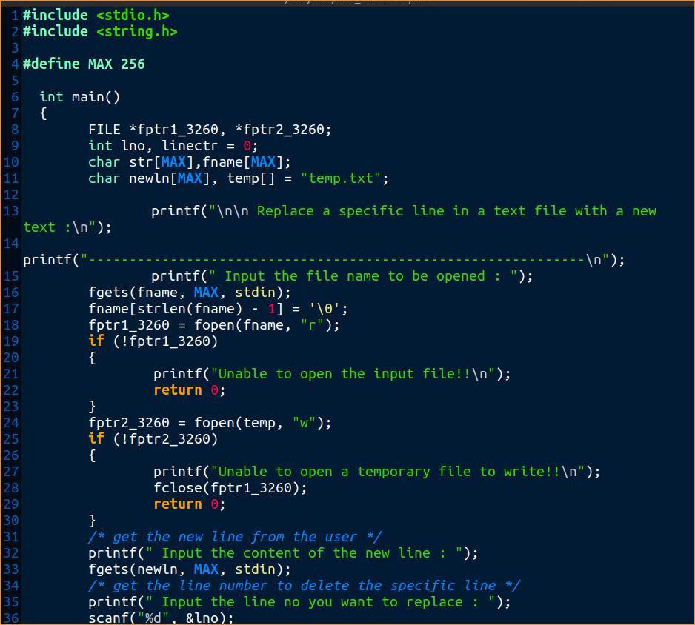

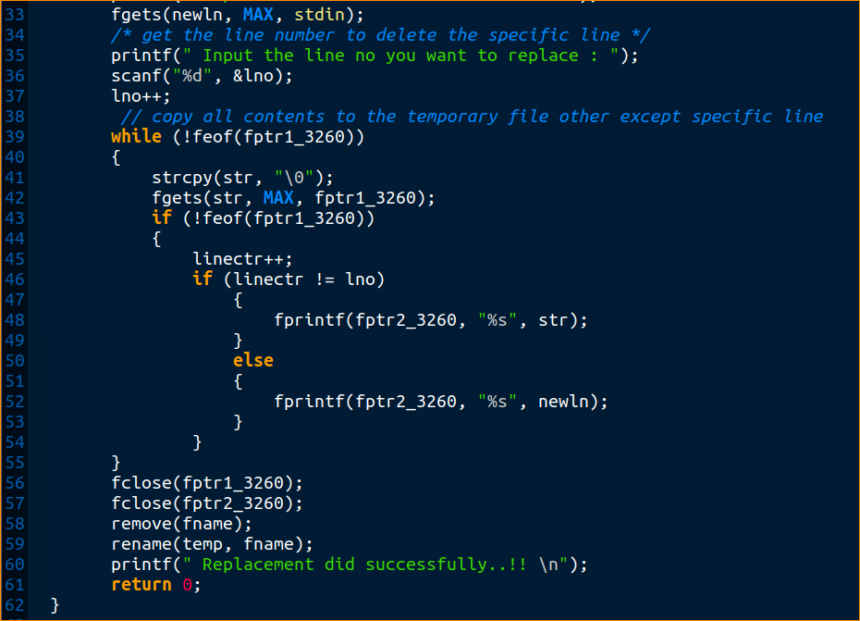

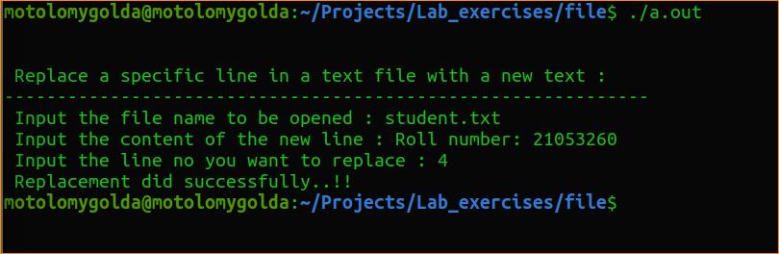

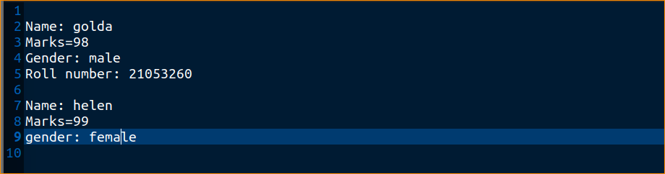

HA10.4 WAP to merge lines alternatively from two files & print the result.

#include <stdio.h>

#include <stdlib.h>

void main()

{

FILE *fold1, *fold2, *fnew;

char ch, fname1_3260[20], fname2_3260[20], fname3_3260[30];

printf("\n\n Merge two files and write it in a new file :\n");

printf("-------------------------------------------------\n");

printf(" Input the 1st file name : ");

scanf("%s",fname1_3260);

printf(" Input the 2nd file name : ");

scanf("%s",fname2_3260);

printf(" Input the new file name where to merge the above two files : ");

scanf("%s",fname3_3260);

fold1=fopen(fname1_3260, "r");

fold2=fopen(fname2_3260, "r");

if(fold1==NULL || fold2==NULL)

{

// perror("Error Message ");

printf(" File does not exist or error in opening...!!\n");

exit(EXIT_FAILURE);

}

fnew=fopen(fname3_3260, "w");

if(fnew==NULL)

{

// perror("Error Message ");

printf(" File does not exist or error in opening...!!\n");

exit(EXIT_FAILURE);

}

while((ch=fgetc(fold1))!=EOF)

{

fputc(ch, fnew);

}

while((ch=fgetc(fold2))!=EOF)

{

fputc(ch, fnew);

}

printf(" The two files merged into %s file successfully..!!\n\n", fname3_3260);

fclose(fold1);

fclose(fold2);

fclose(fnew);

}

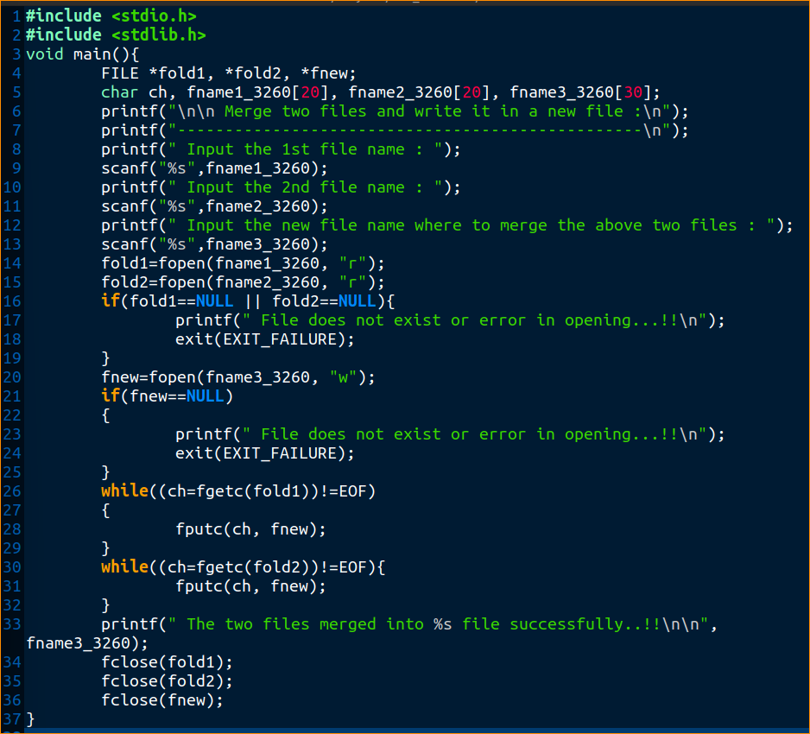

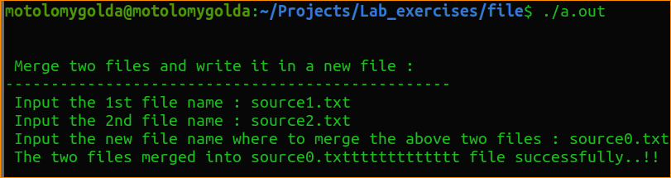

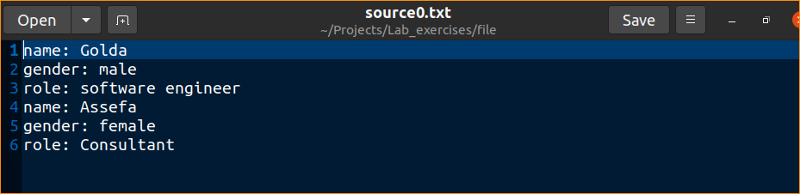

HA10.5 WAP to display the files and sub-directories present in a specified directory

#include <stdio.h>

#include <dirent.h>

int main(void)

{

struct dirent *de;

DIR *dr_3260 = opendir(".");

if (dr_3260 == NULL)

{

printf("Could not open current directory" );

return 0;

}

while ((de = readdir(dr_3260)) != NULL)

printf("%s\n", de->d_name);

closedir(dr_3260);

return 0;

}

